PROGRAM 1: W.A.P. to print “Hello World” or “This is my first C-Program”.

PROGRAM:

#include<stdio.h> void main()

{

prin ("\nThis is my first C-Program");

}

OUTPUT:

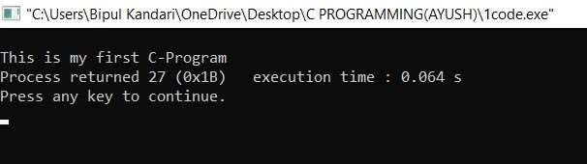

PROGRAM 2: W.A.P. to add two numbers.

PROGRAM:

//Program to add 2 numbers. #include<stdio.h> int main()

{

int num1,num2,sum; prin ("Enter the 1st no.:"); scanf("%d",&num1); prin ("\nEnter the 2nd no.:"); scanf("%d",&num2); sum=num1+num2; prin ("\nThe sum of entered numbers is :%d",sum);

return 0;

}

OUTPUT:

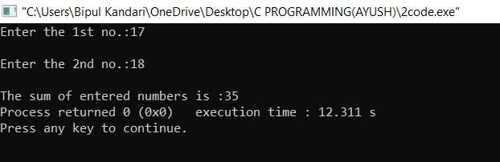

PROGRAM 3: W.A.P. to find area of a circle.

PROGRAM:

//Program to find area of a circle.

#include<stdio.h> int main()

{

int radius,area; prin ("Enter the radius:"); scanf("%d",&radius); area=3.14*radius*radius; prin ("\nThe area of circle is :%d",area); return 0;

}

OUTPUT:

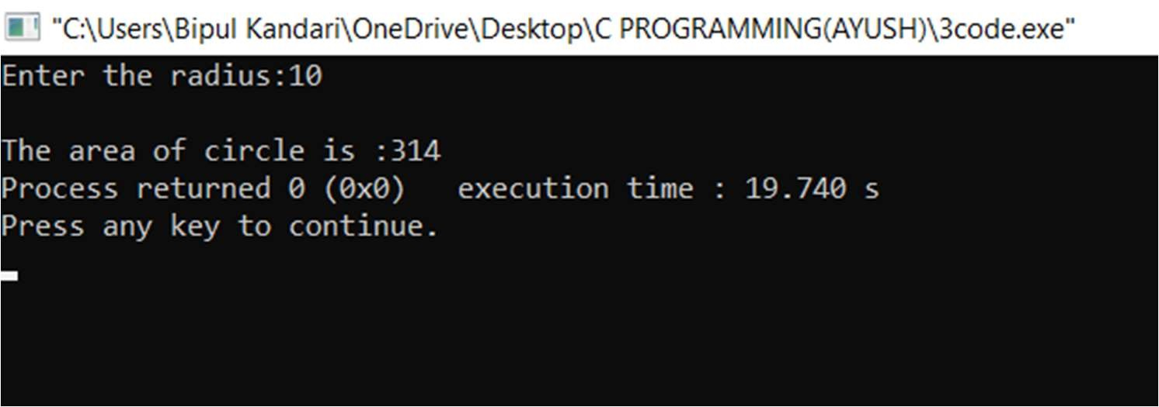

PROGRAM 4: W.A.P. to divide two numbers.

PROGRAM:

//Program to divide 2 numbers.

#include<stdio.h> int main()

{

int num1,num2,division; prin ("Enter the 1st no.:"); scanf("%d",&num1); prin ("\nEnter the 2nd no.:"); scanf("%d",&num2); division=num1/num2; prin ("\nThe division of entered numbers is :%d",division);

return 0;

}

OUTPUT:

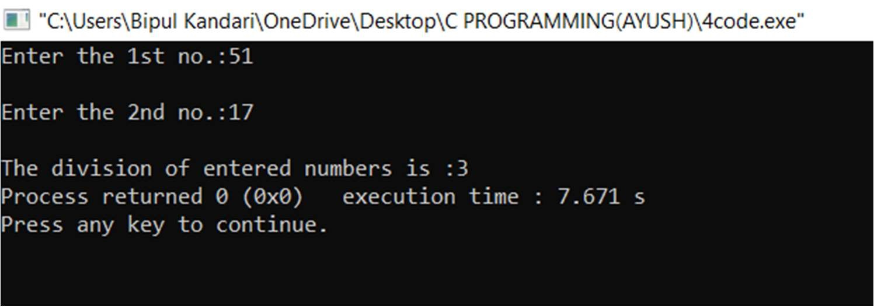

PROGRAM 5: W.A.P. to display ASCII value of a character.

PROGRAM:

//Program to print ASCII values.

#include<stdio.h> int main()

{

char a; prin ("Enter a character: "); scanf("%c",&a); prin ("ASCII value of %c = %d",a,a);

return 0;

}

OUTPUT:

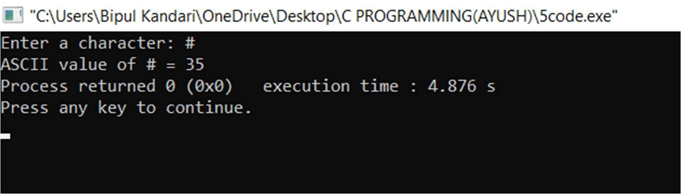

PROGRAM 6: W.A.P. to mul ply floa ng point numbers.

PROGRAM:

//Program to mul ply floa ng point numbers.

#include<stdio.h> int main()

{

float num1,num2,mul plica on; prin ("Enter the 1st no.:"); scanf("%f",&num1); prin ("\nEnter the 2nd no.:"); scanf("%f",&num2); mul plica on=num1*num2; prin ("\nThe mul plica on of entered numbers is :%f",mul plica on);

return 0;

}

OUTPUT:

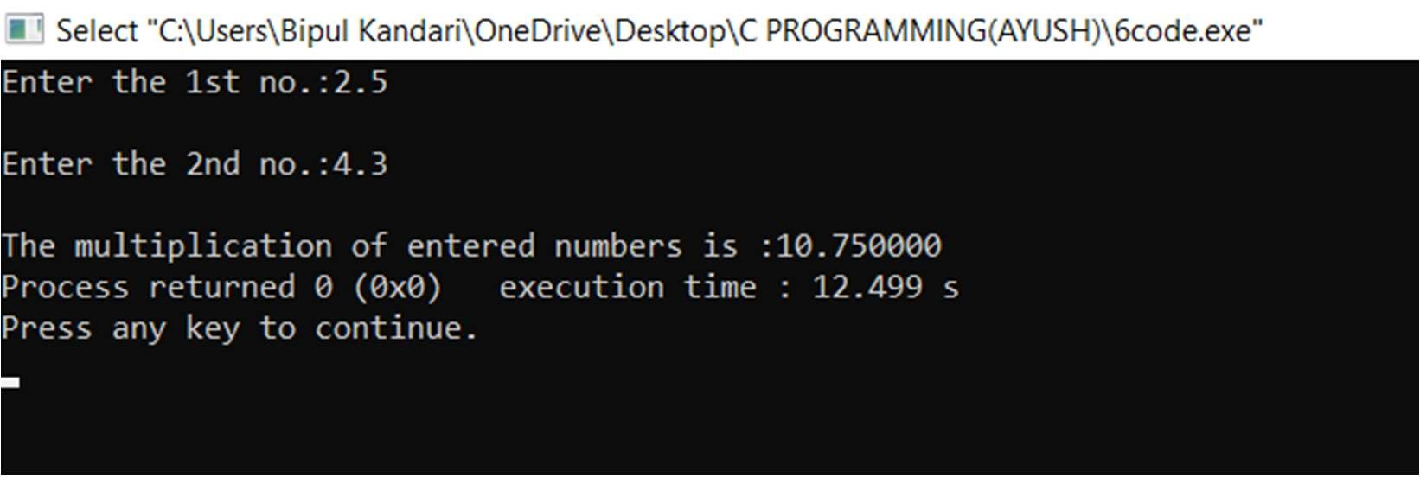

PROGRAM 7: W.A.P. to swap two numbers using 3rd variable.

PROGRAM:

//Program to swap 2 numbers(variables) using 3rd variable.

#include<stdio.h> int main()

{ int a,b,c;

prin ("Enter a no.:"); scanf("%d",&a); prin ("Enter another no.:"); scanf("%d",&b); prin ("Original values of entered nos. are : a=%d, b=%d",a,b);

c=a; a=b; b=c;

prin ("\nValues of a and b a er swapping are : a=%d, b=%d",a,b);

return 0;

}

OUTPUT:

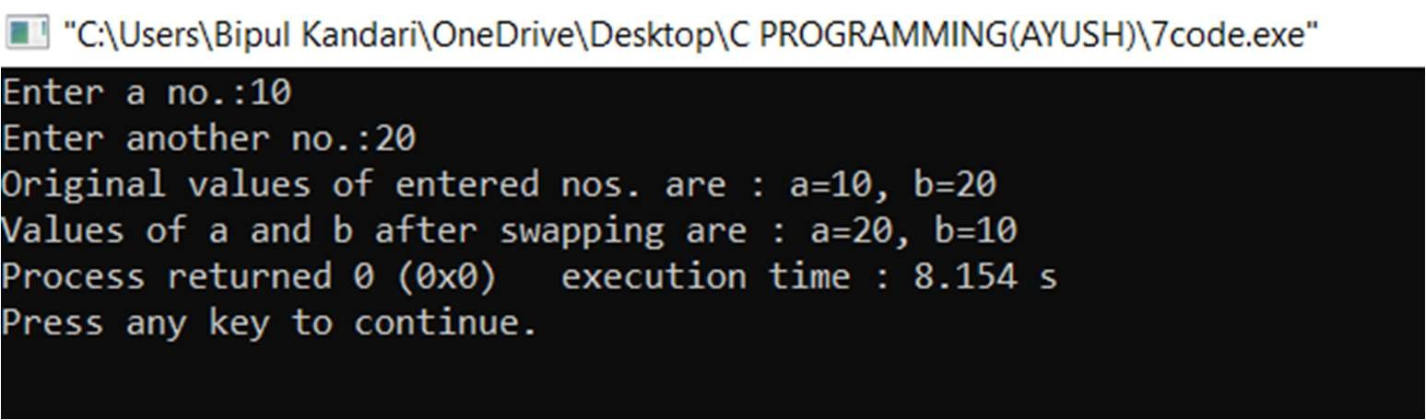

PROGRAM 8: W.A.P. to swap two numbers(variables) without using 3rd variable.

PROGRAM:

//Program to swap 2 numbers(variables) without using 3rd variable.

#include<stdio.h> int main()

{ int a,b;

prin ("Enter a no.:"); scanf("%d",&a); prin ("Enter another no.:"); scanf("%d",&b); prin ("Original values of entered nos. are : a=%d, b=%d",a,b);

a=a+b; b=a-b; a=a-b; prin ("\nValues of a and b a er swapping are : a=%d, b=%d",a,b);

return 0;

}

OUTPUT:

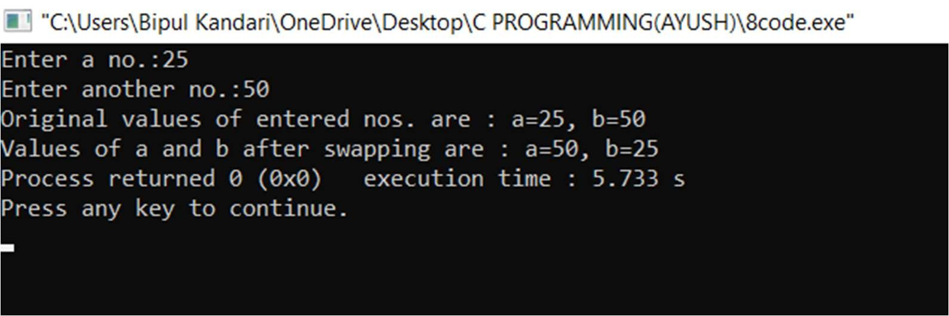

PROGRAM 9: W.A.P. to swap 3 numbers(variables) without using temporary variables.

PROGRAM:

//Program to swap 3 numbers(variables) without using temporary variable.

#include<stdio.h> int main()

{ int a,b,c;

prin ("Enter 3 nos. to swap:"); scanf("%d %d %d",&a,&b,&c); prin ("Original values of entered nos. are : a=%d, b=%d c=%d",a,b,c); c=a+b+c; b=c-b-a; a=c-b-a; c=c-b-a;

prin ("\nValues of a,b and c a er swapping are : a=%d, b=%d, c=%d",a,b,c);

return 0;

}

OUTPUT:

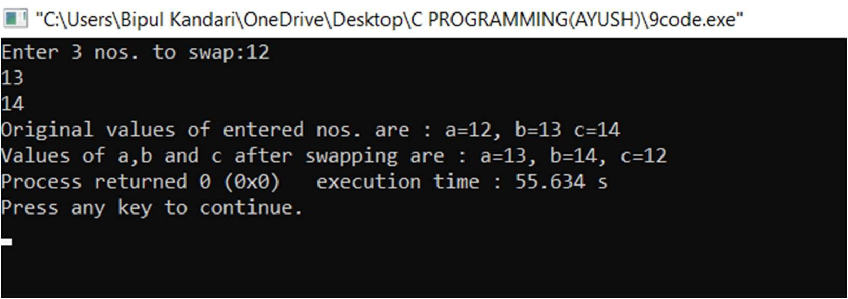

PROGRAM 10: W.A.P. to find area of rectangle.

PROGRAM:

//Program to find area of rectangle.

#include<stdio.h> int main()

{

int length,breadth,area; prin ("Enter the Length of Rectangle : "); scanf("%d", &length); prin ("\nEnter the Breadth of Rectangle : "); scanf("%d", &breadth); area = length * breadth; prin ("\nArea of Rectangle = %d", area);

return (0);

}

OUTPUT:

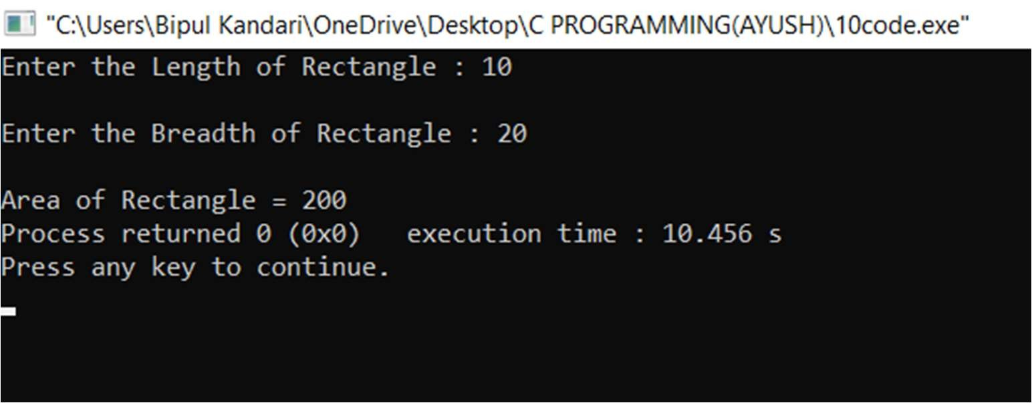

PROGRAM 11: W.A.P. to find area of square.

PROGRAM:

//Program to find area of square.

#include<stdio.h> int main()

{

int side,area; prin ("Enter the Length of Side: "); scanf("%d", &side); area = side * side;

prin ("\nArea of Square: %d", area);

return (0);

}

OUTPUT:

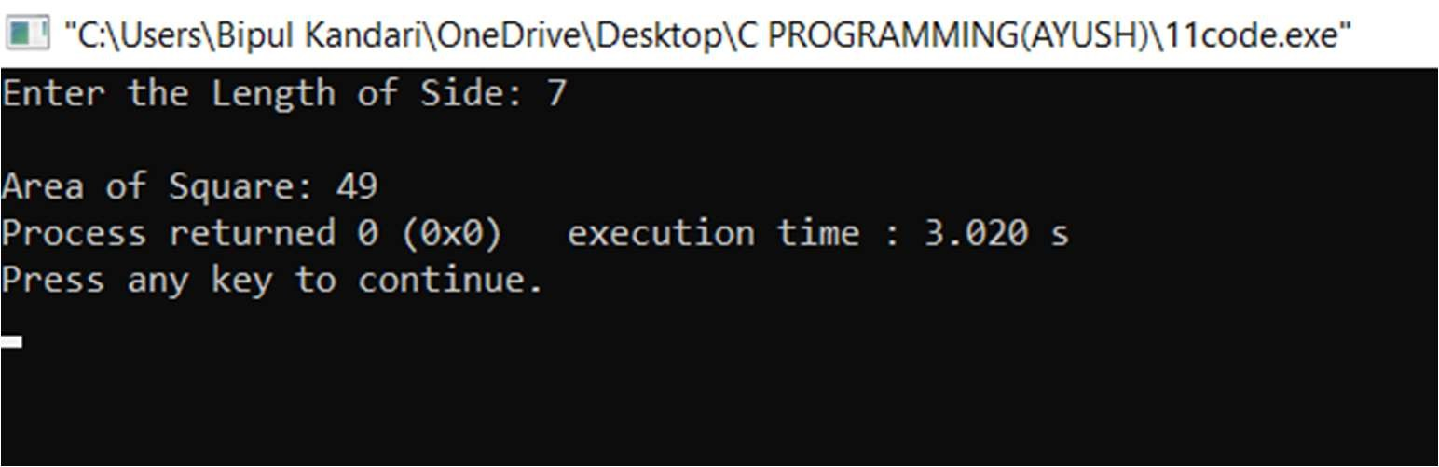

PROGRAM 12: W.A.P. to find area of any triangle.

PROGRAM:

//Program to find area of any kind of triangle.

#include <stdio.h> int main()

{

float base,height,area; prin ("Enter the Base and Height: "); scanf("%f %f",&base,&height); area=(base * height) / 2; prin ("Area of Triangle = %0.2f",area); return 0;

}

OUTPUT:

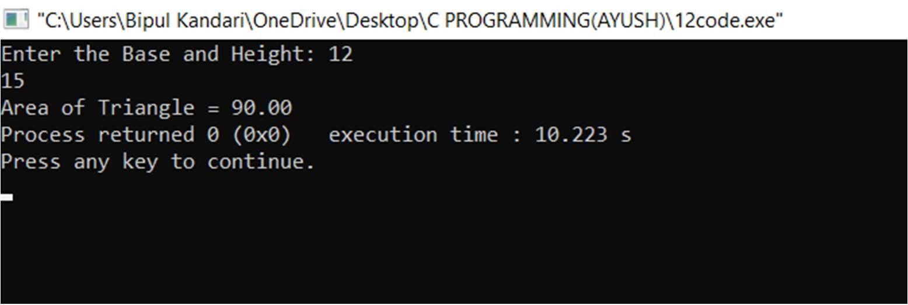

PROGRAM 13: W.A.P. to find area and volume of cube.

PROGRAM:

//Program to find area and volume of cube.

#include <stdio.h> #include <math.h> void main()

{

float side,area,volume; prin ("Enter the length of a side \n"); scanf("%f", &side); area= 6*side*side; volume=pow(side,3); prin ("Area= %f and Volume = %f \n",area,volume);

}

OUTPUT:

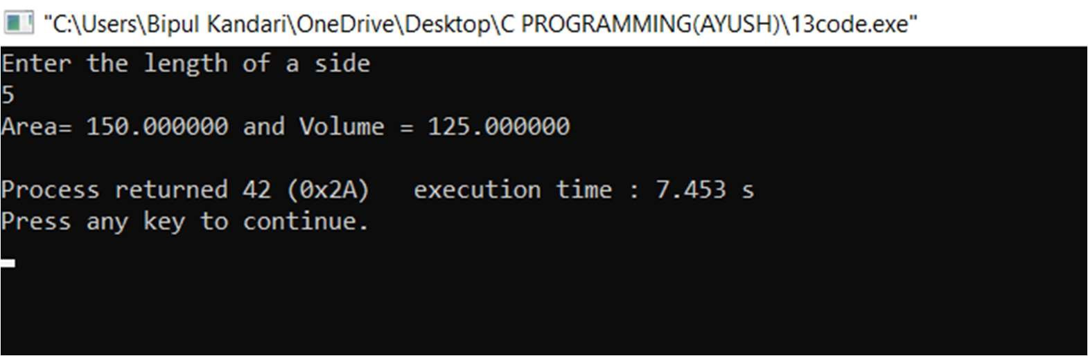

PROGRAM 13: W.A.P. to find area and volume of cuboid.

PROGRAM:

//Program to find area and volume of cuboid.

#include<stdio.h> #include<math.h>

int main()

{

float width,length,height; float surfacearea,volume;

prin ("Enter the value of width,length & height of the cuboid: "); scanf("%f %f %f",&width,&length,&height);

surfacearea= 2*(width*length + length*height + height*width); volume= width*length*height;

prin ("Surface area of cuboid = %.3f", surfacearea); prin ("\nVolume of cuboid = %.3f", volume);

return 0;

}

OUTPUT:

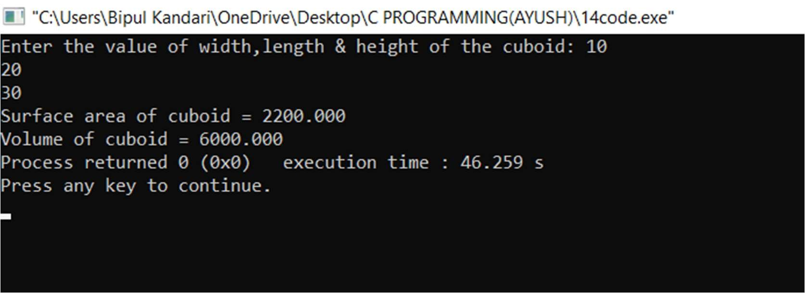

PROGRAM 15: W.A.P. to find SIMPLE INTEREST.

PROGRAM:

//Program to find SIMPLE INTEREST.

#include<stdio.h> int main()

{ int P,T; float SI,R;

printf("Enter the principal amount:"); scanf("%d",&P); printf("Enter the rate of interest:"); scanf("%f",&R); printf("Enter the time(in years):"); scanf("%d",&T); SI=(P*R*T)/100; printf("Simple Interest:%.2f",SI); return 0;

}

OUTPUT:

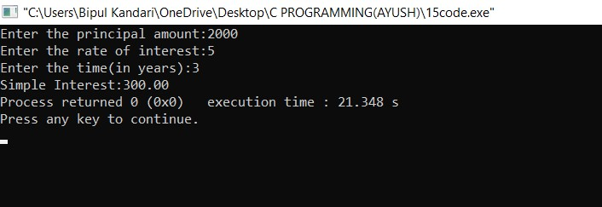

PROGRAM 16: W.A.P. to calculate COMPUND INTEREST.

PROGRAM:

//Program to calculate COMPUND INTEREST.

#include<stdio.h> #include<math.h>

int main()

{ int P,T; float CI,R; printf("Enter principal amount:\nEnter rate of interest: \nEnter time(in years):\n"); scanf("%d %f %d",&P,&R,&T); CI=P*(pow(1+R/T,T)); printf("COMPOUND INTEREST=%0.2f",CI);

return 0;

}

OUTPUT:

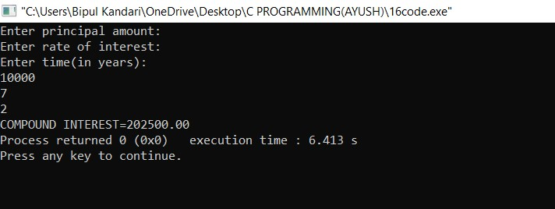

PROGRAM 17: W.A.P. to print your name, age, batch, student ID and course.

PROGRAM:

#include<stdio.h> int main()

{

int age,batch,studentid; char name[20],course; printf("Enter your name:"); scanf("%s",&name[20]); printf("Enter your age:"); scanf("%d",&age); printf("Enter your batch:"); scanf("%d",&batch); printf("Enter Student ID:"); scanf("%d",&studentid); printf("Enter your batch:"); scanf("%s",&course);

printf("\nName: %s \nAge: %d \nBatch: %d \nStudent ID: %d \nCourse: %s", name[20],age,batch,studentid,course);

return 0;

}

OUTPUT:

PROGRAM 18: W.A.P. to convert temperature from Fahrenheit to Celsius.

PROGRAM:

#include<stdio.h> int main()

{

float celsius,fahrenheit; printf("Enter the temperature in fahrenheit:"); scanf("%f",&fahrenheit); celsius=(fahrenheit-32)*5/9; printf("Temperature in celsius scale is: %.3f",celsius); return 0;

}

OUTPUT:

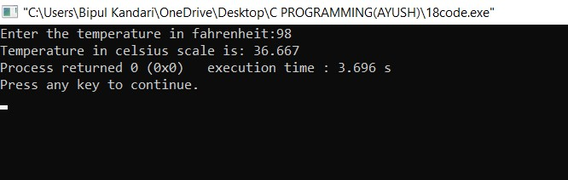

PROGRAM 19: W.A.P. to find the largest number using the logical AND(&&) operator.

PROGRAM:

#include <stdio.h> int main()

{

int a,b,c;

printf("Enter three numbers:"); scanf("%d",&a); scanf("%d",&b); scanf("%d",&c); if (a>b && a>c) printf("Biggest number is %d",a); if (b>a && b>c) printf("Biggest number is %d",b); if (c>a && c>b) printf("Biggest number is %d",c); return 0;

}

OUTPUT:

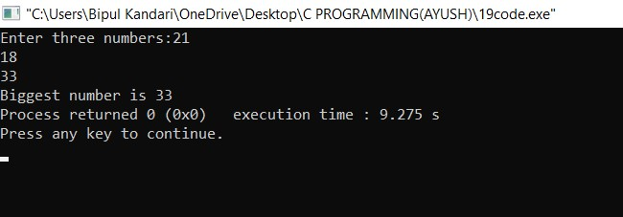

PROGRAM 20: W.A.P. to validate the user-name and password entered by the user is correct or not using the predefined user-name and password.

PROGRAM:

//Program to verify entered user-name and password.

#include<stdio.h>

int main() { char username[] = "Ayush"; char password[] = "nothing"; char username1[20]; char password1[20]; printf("Enter Username : "); gets(username1); printf("Enter Password : "); gets(password1); if((strcmp(username,username1) == 0) && (strcmp(password,password1) ==0 ))

{

printf("Correct");

} else

{

printf("Incorrect");

}

return 0;

}

OUTPUT:

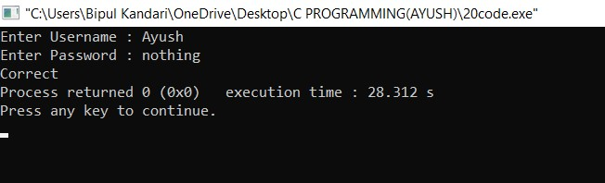

PROGRAM 21: W.A.P. to input the positive number from the user to perform the left shift operation.

PROGRAM:

#include <stdio.h> int main()

{ int x,y;

printf("Enter value for x:"); scanf("%d",&x); printf("Enter number of positions for the bits to shift to the left: ");

// Taking input of the second operand. scanf("%d",&y); printf("After performing left shift operation:");

printf("%d << %d = %d", x, y, x << y); return 0;

}

OUTPUT:

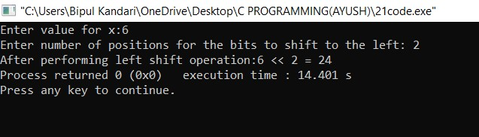

PROGRAM 22: W.A.P. to input the positive number from the user to perform the right shift operation.

PROGRAM:

#include <stdio.h> int main()

{ int x,y;

printf("Enter value for x:"); scanf("%d",&x); printf("Enter number of positions for the bits to shift to the right:");

// Taking input of the second operand. scanf("%d",&y); printf("After performing right shift operation:");

printf("%d >> %d = %d", x, y, x >> y); return 0;

}

OUTPUT:

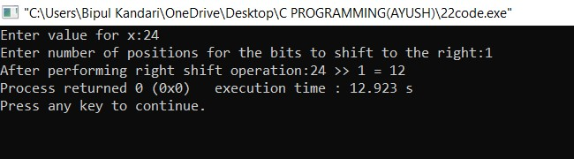

PROGRAM 22: W.A.P. to perform the pre increment and pre decrement operator on two integers and print both original value and updated value.

PROGRAM:

#include <stdio.h> int main ()

{ int a,b; printf ("Enter value for a:" ); scanf("%d",&a); printf ("\nEnter value for b:" ); scanf("%d",&b); printf("\nThe value of a is %d ", a); printf("\nThe value of b is %d ", b);

a=++a; b=--b;

printf("\nAfter using the pre-increment operator,the value of a is: %d",a); printf("\nAfter using the pre-decrement operator,the value of b is: %d",b);

return 0;

}

OUTPUT:

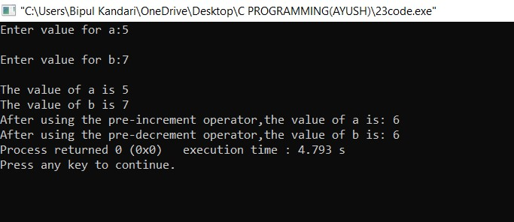

PROGRAM 23: W.A.P. to perform the post increment and post decrement operator on two integers and print both original value and updated value.

PROGRAM:

#include <stdio.h> int main ()

{ int a,b;

printf("Enter value for a:" ); scanf("%d",&a); printf("\nEnter value for b:" ); scanf("%d",&b); printf("\nThe value of a is %d ",a); printf("\nThe value of b is %d ",b);

a++,b--;

printf("\nAfter using the post-increment operator,the value of a is: %d",a); printf("\nAfter using the post-decrement operator,the value of b is: %d",b);

return 0;

}

OUTPUT:

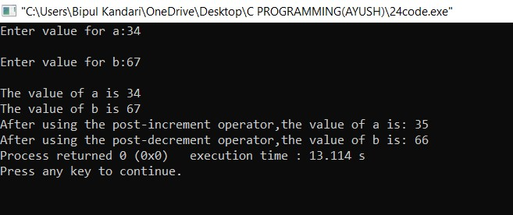

PROGRAM 24: W.A.P. for an integer number and to check whether it is divisible by 9 or 7 using OR logical operator.

PROGRAM:

#include<stdio.h> int main()

{ int x;

printf("Enter an integer number:"); scanf("%d",&x); if((x%7==0)||(x%9==0))

{

printf("\n%d is divisible by either of 7 or 9",x);

}

else

printf("\n%d is NOT divisible by 7 or 9",x);

return 0;

}

OUTPUT:

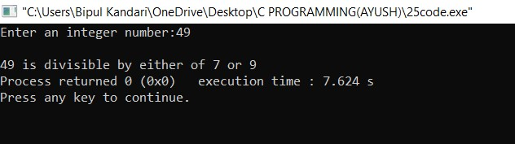

PROGRAM 25: W.A.P. to identify gender in single character and print full gender (e.g. if input is ‘M’ or ‘m’ ,then it should print ‘Male’).

PROGRAM:

#include<stdio.h> int main()

{

char gender; printf("Enter the gender(M/F):"); scanf("%c",&gender); if(gender=='M' || gender=='m')

{

printf("Male");

}

else if(gender=='F' || gender=='f')

{

printf("Female");

}

else printf("Invalid entry");

return 0;

}

OUTPUT:

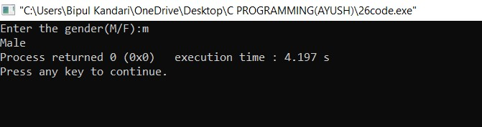

**PROGRAM 26: W.A.P. to print all natural numbers in reverse(from n to 1).**

**PROGRAM:**

#include<stdio.h> int main()

{

printf("AYUSH KANDARI\n"); int num,i; printf("Enter a number:\n"); scanf("%d",&num); for(i=num;i>=1;i--) printf("%d\t",i); return 0;

}

**OUTPUT:**

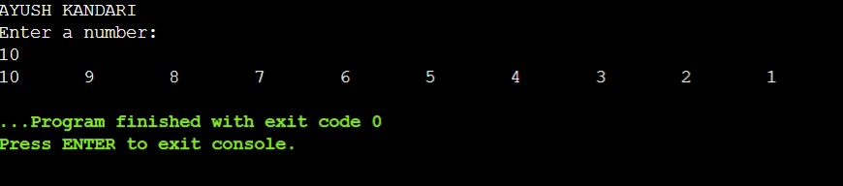

**PROGRAM 26: .P. to all alphabets from A to Z.**

**PROGRAM:**

#include<stdio.h> int main()

{

printf("AYUSH KANDARI\n");

char i; for(i=65;i<=90;i++) printf("%c\t",i); return 0;

}

**OUTPUT:**

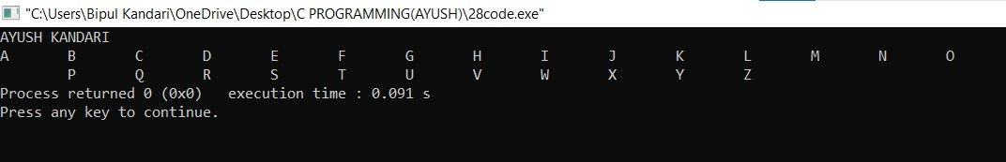

**.P. to all alphabets from A to Z.**

**PROGRAM:**

#include<stdio.h> int main()

{

printf("AYUSH KANDARI\n");

char i; for(i=65;i<=90;i++) printf("%c\t",i); return 0;

}

**OUTPUT:**



**l natural numbers**

**from 1 to n.**

**PROGRAM:**

#include<stdio.h> int main()

{

printf("AYUSH KANDARI\n"); int num,i; printf("Enter a number:\n"); scanf("%d",&num); for(i=1;i<=num;i++) printf("%d\t",i); return 0;

}

**OUTPUT:**

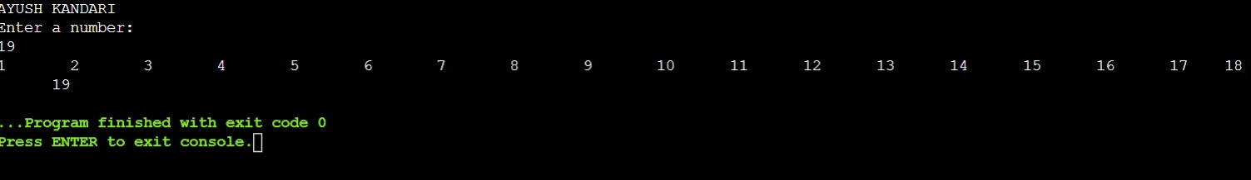

**l even numbers from 1**

**to 100.**

**PROGRAM:**

#include<stdio.h> int main()

{

printf("AYUSH KANDARI\n"); int i;

for(i=2;i<=100;i=i+2) printf("%d\t",i); return 0;

}

**OUTPUT:**

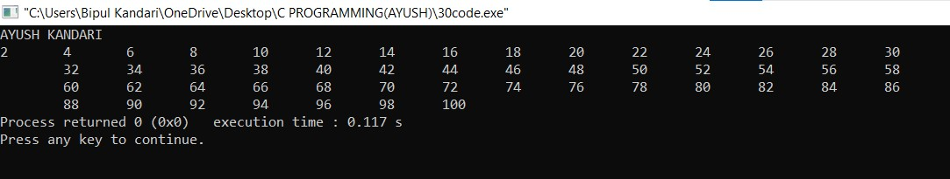

**PROGRAM 30: l odd numbers from 1 to 100.**

**PROGRAM:**

#include<stdio.h> int main()

{

printf("AYUSH KANDARI\n"); int i;

for(i=1;i<=100;i=i+2) printf("%d\t",i); return 0;

}

**OUTPUT:**

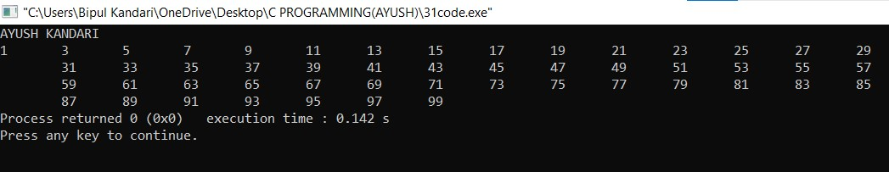

**31: find the sum of all natural**

**numbers between 1 to n.**

**PROGRAM:**

#include<stdio.h> int main()

{

printf("AYUSH KANDARI\n"); int i,num,sum=0; printf("Enter a number:\n"); scanf("%d",&num); for(i=0;i<=num;i++) sum=sum+i; printf("The sum of all natural numbers till

%d=%d",num,sum);

return 0;

}

**OUTPUT:**

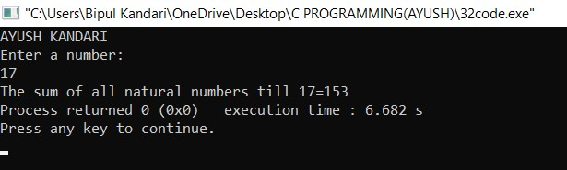

**find sum of all even numbers**

**from 1 to n.**

**PROGRAM:**

#include<stdio.h> int main(){ printf("AYUSH KANDARI\n"); int i,num,sum=0; printf("Enter a number:\n"); scanf("%d",&num); for(i=0;i<=num;i++) if(i%2==0) sum=sum+i; printf("The sum of all even natural numbers till

%d=%d",num,sum);

return 0;

}

**OUTPUT:**

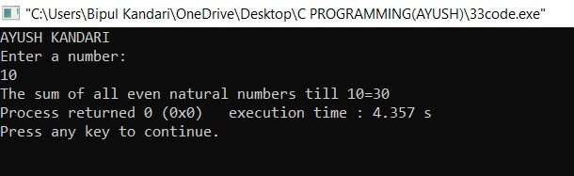

**find sum of all odd numbers**

**from 1 to n.**

**PROGRAM:**

#include<stdio.h> int main(){ printf("AYUSH KANDARI\n"); int i,num,sum=0; printf("Enter a number:\n"); scanf("%d",&num); for(i=0;i<=num;i++) if(i%2!=0) sum=sum+i; printf("The sum of all odd natural numbers till

%d=%d",num,sum);

return 0;

}

**OUTPUT:**

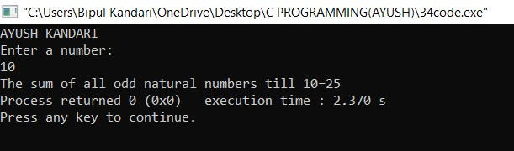

**print multiplication table of**

**any number.**

**PROGRAM:**

#include<stdio.h> int main(){ printf("AYUSH KANDARI\n"); int i,num; printf("Enter a number:\n"); scanf("%d",&num); printf("The table of %d is \n",num); for(i=1;i<=10;i++) printf("%d\n",i*num); return 0;

}

**OUTPUT:**

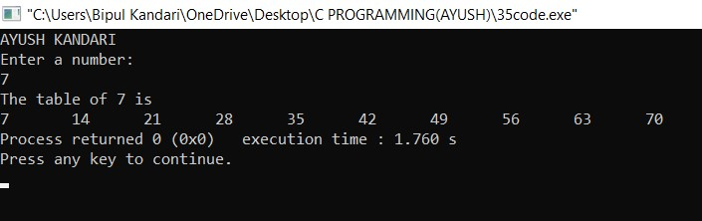

**count number of digits in a**

**number.**

**PROGRAM:**

#include<stdio.h> void main(){ printf("AYUSH KANDARI\n"); int num,count=0; printf("Enter a number:\n"); scanf("%d",&num); while (num>0) { num=num/10; count++;

}

printf("The number of digits in the entered number is: %d",count);

}

**OUTPUT:**

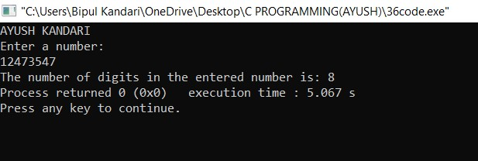

**PROGRAM 36:W.A.P. to display the first and last digit of a number.**

**PROGRAM:**

#include<stdio.h> int main()

{

printf("AYUSH KANDARI\n"); int num,firstdigit,lastdigit; printf("Enter a number:"); scanf("%d",&num); lastdigit=num%10; while(num>=10)

{

num=num/10;

}

firstdigit=num; printf("First digit= %d and Last digit=

%d",firstdigit,lastdigit); return 0;

}

**OUTPUT:**

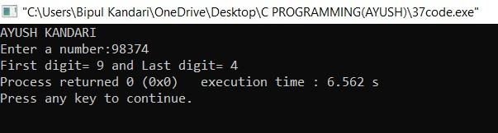

**PROGRAM 37:W.A.P. to find the sum of first and last digit of a number.**

**PROGRAM:**

#include<stdio.h> int main()

{

printf("AYUSH KANDARI\n"); int num,firstdigit,lastdigit; printf("Enter a number:"); scanf("%d",&num); lastdigit=num%10; while(num>=10)

{

num=num/10;

}

firstdigit=num; printf("Sum of first and last digit of the entered number is:

%d+%d=%d",firstdigit,lastdigit,firstdigit+lastdigit); return 0;

}

**OUTPUT:**

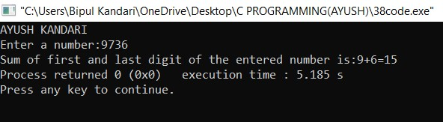

**PROGRAM 38: W.A.P. to swap the first and last digit of a number.**

**PROGRAM:**

#include<stdio.h> int main(){ printf("AYUSH KANDARI\n"); int num,firstdigit,lastdigit,digits,swappednumber; printf("Enter number= "); scanf("%d",&num); lastdigit=num%10; digits=(int)log10(num); firstdigit=(int)(num/pow(10,digits)); swappednumber=lastdigit; swappednumber*=(int)round(pow(10,digits)); swappednumber+=num%((int)round(pow(10,digits))); swappednumber-=lastdigit; swappednumber+=firstdigit; printf("Number after swapping first and last digit:

%d",swappednumber);

return 0;

}

**OUTPUT:**

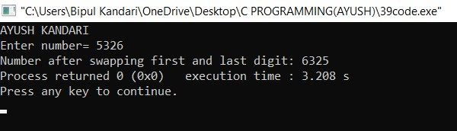

**PROGRAM 39 calculate the sum of digits of a number.**

**PROGRAM:**

#include<stdio.h> int main()

{

printf("AYUSH KANDARI\n"); int num,sum=0; printf("Enter a number:"); scanf("%d",&num); while(num>0)

{

sum=sum+num%10; num/=10;

}

printf("\nThe sum of the digits of the entered number is=%d",sum);

return 0;

}

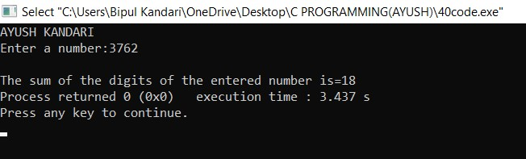

**PROGRAM 40 calculate the product of digits of a number.**

**PROGRAM:**

#include<stdio.h> int main()

{

printf("AYUSH KANDARI\n"); int num,product=1; printf("Enter a number:"); scanf("%d",&num); while(num>0)

{

product*=num%10; num/=10;

}

printf("\nThe product of the digits of the entered number is=%d",product);

return 0;

}

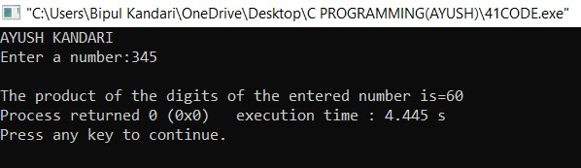

**PROGRAM 41 reverse the digits of a number.**

**PROGRAM:**

#include<stdio.h> int main()

{

printf("AYUSH KANDARI\n"); int num,reverse=0,rem; printf("Enter a number:"); scanf("%d",&num); while(num>0)

{

rem=num%10; reverse=reverse*10+rem; num/=10;

}

printf("The reversed number is:%d",reverse); return 0;

}

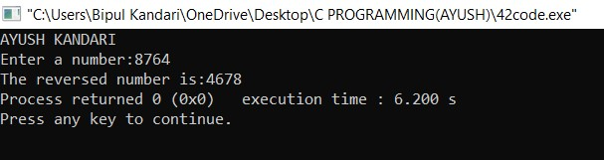

**PROGRAM 43: W.A.P. to find frequency of each digit in a given number.**

**PROGRAM:**

#include<stdio.h> int main()

{

printf("AYUSH KANDARI\n"); int num,count=0,lastdig,a; printf("Enter the number:"); scanf("%d",&num); printf("Enter digit to be counted:\n"); scanf("%d",&a); while(num != 0)

{

lastdig=num%10; if(lastdig==a) count++; num/=10;

}

printf("Number of times %d appeared in the entered number is %d",a,count);

return 0;

}

**OUTPUT:**

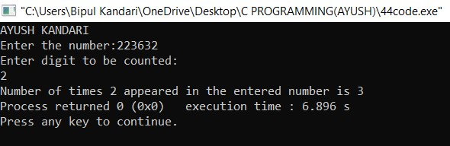

**PROGRAM 44: W.A.P. to enter a number and print it in words.**

**PROGRAM:**

#include<stdio.h> #include<string.h> printf("AYUSH KANDARI\n"); int main(){ int num; char*firstnum[]={"zero","ten","eleven","twelve",

"thirteen", "fourteen","fifteen","sixteen", "seventeen","eighteen","nineteen"}; char*secondnum[]={"twenty","thirty","forty","fifty",

"sixty", "seventy","eighty","ninety"}; char*thirdnum[]={"one","two","three","four","five",

"six","seven","eight","nine"}; printf("Enter a number:"); scanf("%d",&num); if(num<0 || num>99) printf("Entered number is not a two digit number"); else if(num==0)

printf("Entered number is:%s",firstnum[num]); else if(num>=10 && num<=19) printf("Entered number is:%s",firstnum[num-

10+1]); else if(num>=20 && num<=90) if(num%10 == 0) printf("Entered number is:%s",secondnum[num/10 - 2]); else printf("Enter number is:%s

%s",secondnum[num/10-2],thirdnum[num%10-1]); return 0;

}

**OUTPUT:**

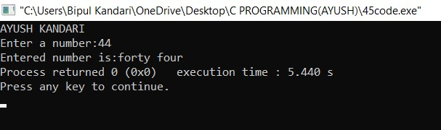

**PROGRAM 46: W.A.P. to find power of a number using for loop.**

**PROGRAM:**

#include<stdio.h> int main()

{

printf("AYUSH KANDARI\n"); int i,pow,num,og; printf("Enter a number:\n"); scanf("%d",&num); printf("Enter the power for the number:\n"); scanf("%d",&pow); og=num; for(i=1;i<=pow-1;i++)

{

num=num*og;

}

printf("%d",num); return 0;

}

**OUTPUT:**

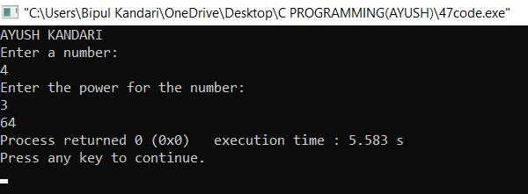

**PROGRAM 47: W.A.P. to find all factors of a number.**

**PROGRAM:**

#include<stdio.h> int main(){ printf("AYUSH KANDARI\n"); int num,i; printf("Enter a number:\n"); scanf("%d",&num); for(i=1;i<=num;i++)

{

if(num%i==0) printf("%d\t",i);

}

return 0;

}

**OUTPUT:**

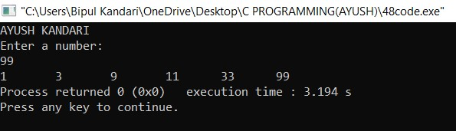

**PROGRAM 49: W.A.P. to calculate factorial of a number.**

**PROGRAM:**

#include<stdio.h> int main()

{

printf("AYUSH KANDARI\n"); int num,i,factorial=1; printf("Enter a number:\n"); scanf("%d",&num); for(i=num;i>=1;i--)

{

factorial=factorial*i;

}

printf("Factorial=%d",factorial); return 0;

}

**OUTPUT:**

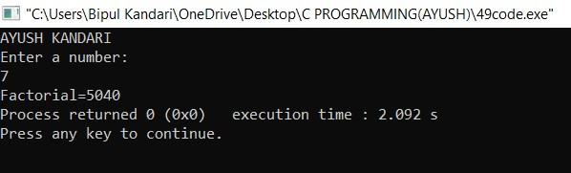

**50: W.A.P. to find HCF(GCD) of two numbers.**

**PROGRAM:**

#include<stdio.h> int main()

{

printf("AYUSH KANDARI\n"); int num1,num2,i,min,HCF=1; printf("Enter first number:"); scanf("%d",&num1); printf("\nEnter second number:"); scanf("%d",&num2); if(num1<num2) for(i=1;i<=num1;i++)

{

if(num1%i==0 && num2%i==0)

HCF=i;

}

else for(i=1;i<=num2;i++) {

if(num1%i==0 && num2%i==0)

HCF=i;

}

printf("HCF=%d",HCF); return 0;

}

**OUTPUT:**

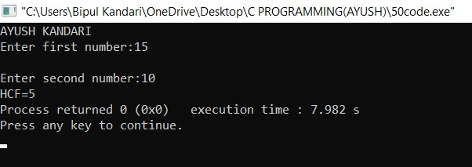

**51: W.A.P. to find LCM of two numbers.**

**PROGRAM:**

#include<stdio.h> int main()

{

printf("AYUSH KANDARI\n"); int num1,num2,max; printf("Enter first number:"); scanf("%d",&num1); printf("\nEnter second number:"); scanf("%d",&num2); max=(num1>num2)?num1:num2;

while(1)

{

if((max%num1==0) && (max%num2==0))

{

printf("\nThe LCM of %d and %d = %d.", num1,num2,max);

break;

}

++max;

}

return 0;

}

**OUTPUT:**

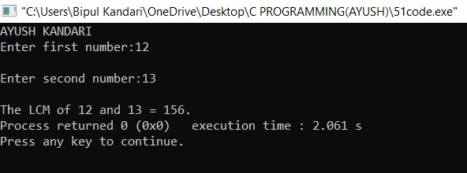

**52 to check whether a number is**

**prime or not.**

**PROGRAM:**

#include<stdio.h> int main()

{

printf("AYUSH KANDARI\n"); int num,i,count=0; printf("Enter a number:"); scanf("%d",&num); for(i=1;i<=num;i++)

{

if(num%i==0) count++;

}

if(count!=2) printf("NOT a PRIME NUMBER"); else

printf("PRIME NUMBER"); return 0;

}

**OUTPUT:**

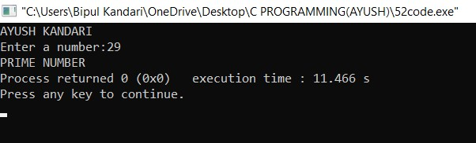

**53 print all prime numbers**

**between 1 to n.**

**PROGRAM:**

#include<stdio.h> int main()

{

printf("AYUSH KANDARI\n"); int num,i,count,n; printf("Enter number:"); scanf("%d",&n); for(num=1;num<=n;num++)

{

count=0; for(i=2;i<=num/2;i++)

{

if(num%i==0)

{ count++; break;

}

}

if(count==0 && num!=1) printf("%d ",num);

}

return 0;

}

**OUTPUT:**

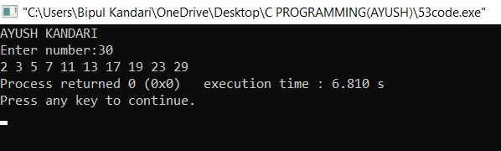

**54 find sum of all prime**

**numbers between 1 to n.**

**PROGRAM:**

#include <stdio.h> int main()

{

printf("AYUSH KANDARI\n"); int i,j,end,isPrime,sum=0; printf("Enter number till which prime nos. should be added:"); scanf("%d",&end); for(i=2;i<=end;i++)

{

isPrime=1; for(j=2;j<=i/2;j++)

{ if(i%j==0)

{

isPrime=0; break;

}

}

if(isPrime==1)

{

sum+=i;

}

}

printf("Sum of all prime numbers between 1 to

%d=%d",end,sum);

return 0;

}

**OUTPUT:**

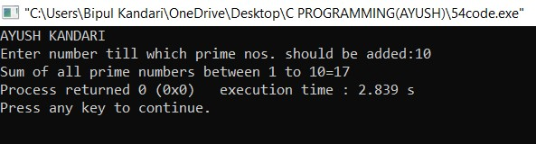

**55 find all prime factors of a number.**

**PROGRAM:**

#include <stdio.h> int main()

{

printf("AYUSH KANDARI\n"); int i,j,num,isPrime; printf("Enter number whose Prime factors you want:"); scanf("%d",&num); printf("All Prime Factors of %d are:\n",num); for(i=2;i<=num;i++)

{

if(num%i==0)

{

isPrime=1; for(j=2;j<=i/2;j++)

{ if(i%j==0)

{

isPrime=0; break;

}

}

if(isPrime==1)

{

printf("%d\t",i);

}

}

}

return 0;

}

**OUTPUT:**

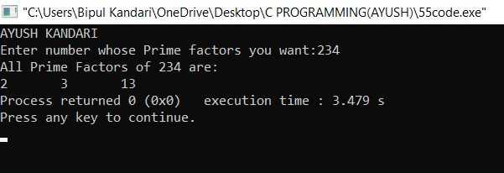

**PROGRAM 56: W.A.P. to check whether a number is Armstrong number or not.**

**PROGRAM:**

#include <stdio.h> int main() { printf("AYUSH KANDARI\n"); int num,originalNum,remainder,result=0; printf("Enter a three-digit integer:"); scanf("%d",&num); originalNum=num; while(originalNum!=0)

{

remainder=originalNum%10; result+=remainder*remainder*remainder; originalNum/=10;

}

if(result==num) printf("%d is an Armstrong number",num); else

printf("%d is not an Armstrong number",num); return 0;

}

**OUTPUT:**

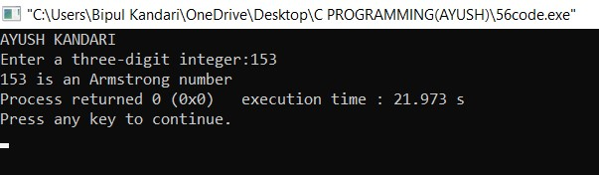

**PROGRAM 57: W.A.P. to print all Armstrong numbers between 1 to n.**

**PROGRAM:**

#include<stdio.h> int main()

{

printf("AYUSH KANDARI\n"); int num,i,rem,sum,temp; printf("Enter number till which Armstrong Nos. should be printed:"); scanf("%d",&num); for(i=1;i<=num;i++)

{

temp=i; sum=0; while(temp!=0)

{

rem=temp%10; sum=sum+rem*rem*rem; temp=temp/10;

}

if(i==sum) printf("%d\t",i);

}

return 0;

}

**OUTPUT:**

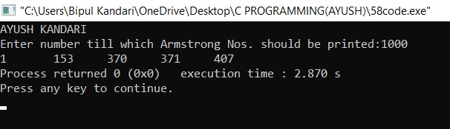

**PROGRAM 58: W.A.P. to check whether a number is perfect number or not.**

**PROGRAM:**

#include<stdio.h> int main()

{

printf("AYUSH KANDARI\n"); int num,i,sum=0;

printf("Enter a number to be checked if it is PERFECT NO.:"); scanf("%d",&num); for(i=1;i<=num/2;i++)

{

if(num%i==0)

{

sum=sum+i;

}

}

if(sum==num) printf("It is a PERFECT NUMBER."); else

printf("NOT a PERFECT NUMBER."); return 0;

}

**OUTPUT:**

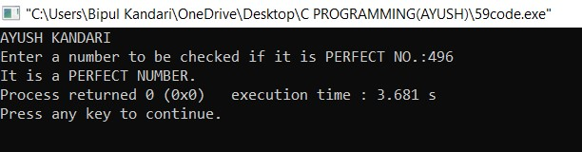

**PROGRAM 59: W.A.P. to print all Perfect Nos. between 1 to n.**

**PROGRAM:**

#include<stdio.h> int main()

{

printf("AYUSH KANDARI\n"); int num,n,i,sum; printf("Enter a number till which PERFECT Nos. should be printed:"); scanf("%d",&num); for(n=1;n<=num;n++)

{

sum=0; for(i=1;i<=n/2;i++)

{

if(n%i==0)

{

sum=sum+i;

}

}

if(sum==n) printf("%d\t",sum);

}

return 0;

}

**OUTPUT:**

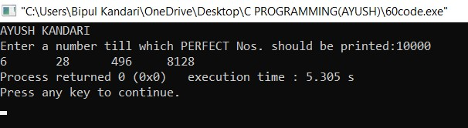

**PROGRAM 60: W.A.P. to check whether a number is Strong number or not.**

**PROGRAM:**

#include<stdio.h> int factorial(int num) { if (num==0 || num==1) {

return 1;

} else {

return num*factorial(num-1);

}

}

int isStrongNumber(int number) { int originalNumber = number; int sum = 0; while (number != 0) { int digit = number % 10; sum += factorial(digit); number /= 10;

}

return (sum == originalNumber);

}

int main() { int number; printf("Enter a number:"); scanf("%d", &number); if (isStrongNumber(number)) { printf("%d is a Strong number.\n",number);

} else {

printf("%d is not a Strong number.\n",number);

}

return 0;

}

**OUTPUT:**

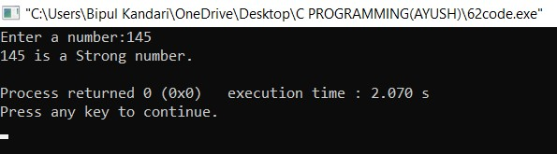

**PROGRAM 61: W.A.P. to print all Strong numbers between 1 to n.**

**PROGRAM:**

#include<stdio.h> int factorial(int num){ if (num==0 || num==1){

return 1;

} else{

return num*factorial(num-1);

}

}

int isStrongNumber(int number){ int originalNumber=number; int sum=0; while(number!=0){ int digit=number%10; sum+=factorial(digit); number /=10;

}

return (sum==originalNumber);

}

int main() { printf("AYUSH KANDARI\n");

int n; printf("Enter a value of n: "); scanf("%d",&n); printf("Strong numbers between 1 and %d are:

\n",n); for (int i=1;i<=n;i++) { if (isStrongNumber(i)) { printf("%d\n",i);

}

}

return 0;

}

**OUTPUT:**

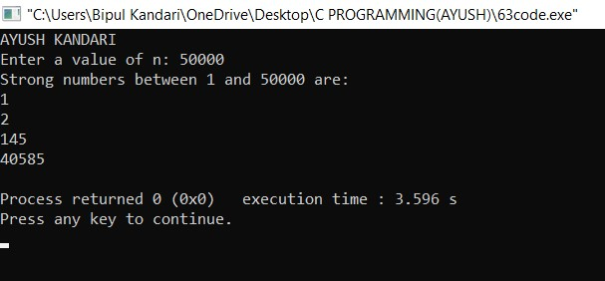

**2 Write a C program to print Fibonacci**

**series up to n terms.**

**PROGRAM:**

#include<stdio.h> void printFibonacci(int n){ int first=0,second=1,next; printf("Fibonacci Series up to %d terms:\n",n); for(int i=1;i<=n;i++){ printf("%d,",first); next=first+second; first=second; second=next;

}

}

int main(){

int n;

printf("AYUSH KANDARI\n"); printf("Enter the number of terms:"); scanf("%d",&n); printFibonacci(n);

return 0;

}

**OUTPUT:**

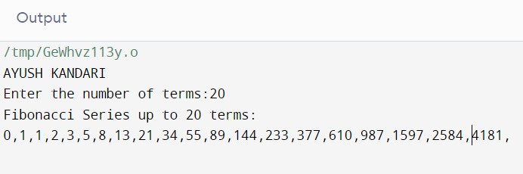

**3 Write a C program to find one's**

**complement of a binary number.**

**PROGRAM:**

#include<stdio.h> #include<string.h> void findOnesComplement(char binaryNumber[]){ int length=strlen(binaryNumber); printf("One's complement of the binary number is:"); for(int i=0;i<length;i++){ if(binaryNumber[i]=='0'){ printf("1");

} else if(binaryNumber[i]=='1'){ printf("0");

} else{ printf("\nInvalid binary number.\n"); return;

}

}

}

int main(){

printf("AYUSH KANDARI\n"); char binaryNumber[100]; printf("Enter a binary number: "); scanf("%s",binaryNumber); findOnesComplement(binaryNumber); return 0;

}

**OUTPUT:**

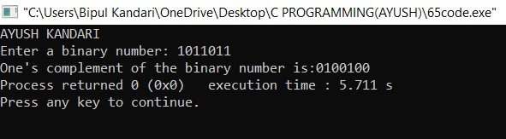

**4 Write a C program to find two's**

**complement of a binary number.**

**PROGRAM:**

#include<stdio.h> #include<string.h> void reverse(char binaryNumber[]){ int length=strlen(binaryNumber); for(int i=0;i<length;i++){ if(binaryNumber[i]=='0'){ binaryNumber[i]='1'; } else if(binaryNumber[i]=='1'){ binaryNumber[i]='0';

}

}

}

void addOne(char binaryNumber[]){ int length=strlen(binaryNumber); int carry=1; for(int i=length-1;i>=0;i--){ if(binaryNumber[i]=='1' && carry==1){ binaryNumber[i]='0';

} else if(binaryNumber[i]=='0' && carry==1){ binaryNumber[i]='1'; carry=0;

}

}

}

int main(){ printf("AYUSH KANDARI\n"); char binaryNumber[100]; printf("Enter a binary number:"); scanf("%s",binaryNumber);

reverse(binaryNumber); addOne(binaryNumber);

printf("Two's complement of the binary number is:%s\n",binaryNumber);

return 0;

}

**OUTPUT:**

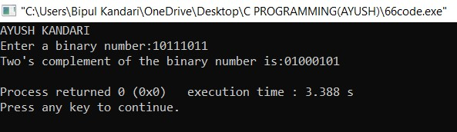

**5**

**Octal number system.**

**PROGRAM:**

#include<stdio.h> void convertBinaryToOctal(long long binaryNumber){ int octalNumber=0,decimalNumber=0,i=0; while(binaryNumber!=0){ decimalNumber+=(binaryNumber%10)*(1<<i);

++i;

binaryNumber/=10;

} i=1;

while(decimalNumber!=0){ octalNumber+=(decimalNumber%8)*i; decimalNumber/=8;

i*=10;

}

printf("Octal number:%d",octalNumber);

}

int main(){

printf("AYUSH KANDARI\n");

long long binaryNumber; printf("Enter a binary number:"); scanf("%lld",&binaryNumber); convertBinaryToOctal(binaryNumber); return 0;

}

**OUTPUT:**

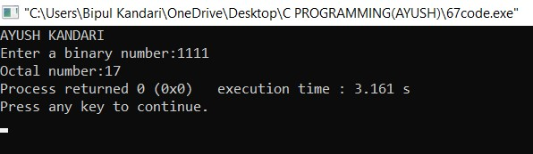

**6**

**Decimal number system.**

**PROGRAM:**

#include<stdio.h> void convertBinaryToDecimal(long long binaryNumber){ int decimalNumber=0,base=1,remainder; while(binaryNumber>0){ remainder=binaryNumber%10; decimalNumber+=remainder*base; binaryNumber/=10; base*=2;

}

printf("Decimal number:%d",decimalNumber);

}

int main(){ printf("AYUSH KANDARI\n"); long long binaryNumber; printf("Enter a binary number:"); scanf("%lld",&binaryNumber); convertBinaryToDecimal(binaryNumber); return 0;

}

**OUTPUT:**

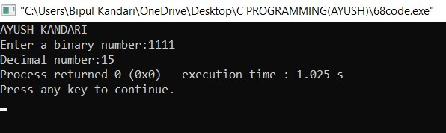

**7**

**Decimal number system.**

**PROGRAM:**

#include<stdio.h> void convertBinaryToDecimal(long long binaryNumber)

{

int decimalNumber=0,base=1,remainder; while(binaryNumber>0){ remainder=binaryNumber%10; decimalNumber+=remainder*base; binaryNumber/=10; base*=2;

}

printf("Decimal number: %d",decimalNumber);

}

int main(){ printf("AYUSH KANDARI\n"); long long binaryNumber; printf("Enter a binary number:"); scanf("%lld",&binaryNumber); convertBinaryToDecimal(binaryNumber); return 0;

}

**OUTPUT:**

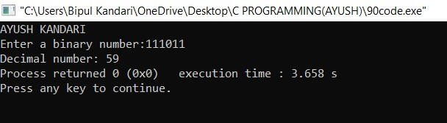

**8 Write a C program to convert Octal to Hexadecimal number system .**

**PROGRAM:**

#include <stdio.h> #include <math.h> int convertOctalToDecimal(int octalNumber) { int decimalNumber=0,i=0; while(octalNumber!=0){ decimalNumber+=(octalNumber%10)*pow(8,i);

++i;

octalNumber/=10;

}

return decimalNumber;

}

void convertDecimalToHexadecimal(int decimalNumber) { char hexadecimalNumber[100];

int i=0;

while(decimalNumber!=0){ int temp=0; temp=decimalNumber%16; if (temp<10){ hexadecimalNumber[i]=temp+48; i++; } else{

hexadecimalNumber[i]=temp+55; i++;

}

decimalNumber/=16;

}

printf("Hexadecimal number:"); for (int j=i-1;j>=0;j--) { printf("%c",hexadecimalNumber[j]);

}

}

int main(){ printf("AYUSH KANDARI\n"); int octalNumber; printf("Enter an octal number:"); scanf("%d",&octalNumber);

int

decimalNumber=convertOctalToDecimal(octalNumber)

;

convertDecimalToHexadecimal(decimalNumber); return 0;

}

**OUTPUT:**

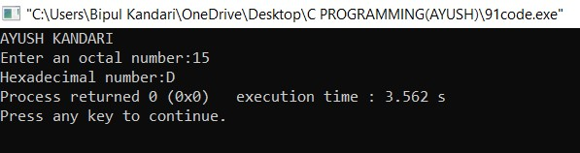

**PROGRAM 74: Write a program to print the Pyramid star pattern.**

**PROGRAM:**

#include<stdio.h> int main(){ printf("AYUSH KANDARI\n"); int rows; printf("Enter number of rows of pyramid:"); scanf("%d",&rows); for(int i=1;i<=rows;i++){ for(int j=rows;j>i;j--){ printf(" ");

}

if(i%2==1){ for(int k=0;k<i;k++){ printf("* ");

}

}

printf("\n");

}

return 0;

}

**OUTPUT:**

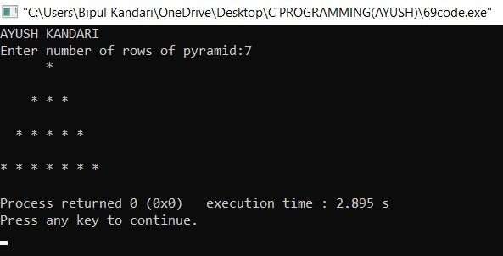

**75: Write a program to print the Hollow Pyramid Star Pattern.**

**PROGRAM:**

#include <stdio.h> int main()

{

printf("AYUSH KANDARI\n");

int i,j,rows; printf("Enter number of rows:"); scanf("%d",&rows); for(i=1;i<=rows;i++)

{

for(j=i;j<rows;j++)

{ printf(" ");

}

for(j=1;j<=(2*i-1);j++)

{

if(i==rows || j==1 || j==(2*i-1))

{

printf("*");

} else { printf(" ");

}

}

printf("\n");

}

return 0;

}

**OUTPUT:**

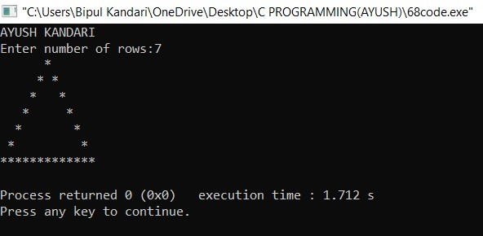

**76 Write a program to print the Inverted Pyramid Star Pattern.**

**PROGRAM:**

#include<stdio.h> int main(){ printf("AYUSH KANDARI\n"); int rows; printf("Enter the number of rows: "); scanf("%d",&rows); for(int i=rows;i>=1;i--){ for(int k=i;k<=rows;k++){ printf(" ");

}

for(int j=i;j>=1;j--){ printf("* ");

}

printf("\n");

}

return 0;

}

**OUTPUT:**

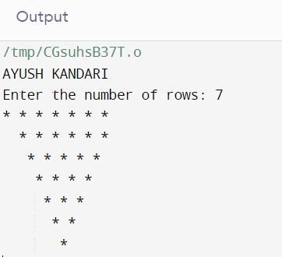

**77 Write a program to print the hollow**

**inverted pyramid star pattern.**

**PROGRAM:**

#include<stdio.h> int main()

{

printf("AYUSH KANDARI\n");

int i,j,rows; printf("Enter number of rows:"); scanf("%d",&rows); for(i=1;i<=rows;i++)

{

for(j=1;j<i;j++)

{ printf(" ");

}

for(j=1;j<=(rows*2-(2*i-1));j++)

{

if(i==1 || j==1 || j==(rows*2-(2*i-1)))

{

printf("*");

} else { printf(" ");

}

}

printf("\n");

}

return 0;

}

**OUTPUT:**

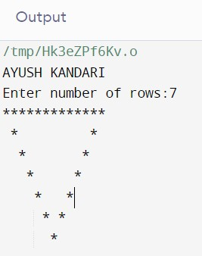

**78 Write a program to print half diamond**

**star pattern.**

**PROGRAM:**

#include<stdio.h> int main(){ printf("AYUSH KANDARI\n"); int rows; printf("Enter the number of rows: "); scanf("%d",&rows); for(int i=1;i<=rows;i++){ for(int k=rows;k>=i;k--){ printf(" ");

}

for(int j=1;j<=i;j++){ printf("* ");

}

printf("\n");

}

for(int i=rows-1;i>=1;i--){ for(int k=i;k<=rows;k++){ printf(" ");

}

for(int j=i;j>=1;j--){ printf("* ");

}

printf("\n");

}

return 0;

}

**OUTPUT:**

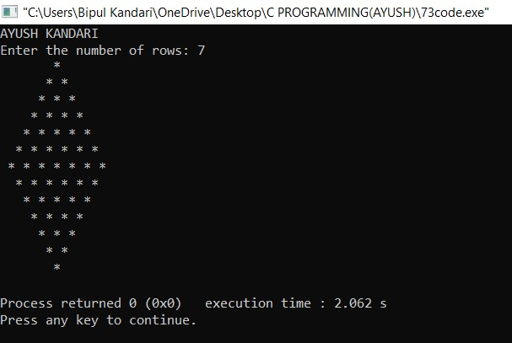

**79:**

**- 1.**

#include<stdio.h> int main(){ printf("AYUSH KANDARI\n"); int num; printf("Enter the number of rows: "); scanf("%d",&num); for(int i=0;i<num;i++){ for(int j=0;j<num;j++){ printf("1");

}

printf("\n");

}

return 0;

}

**OUTPUT:**

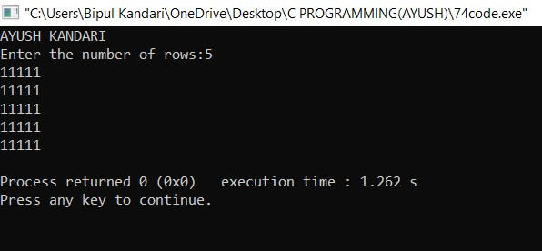

**80:**

**– 2.**

#include<stdio.h> int main(){ printf("AYUSH KANDARI\n"); int rows; printf("Enter the number of rows: "); scanf("%d",&rows); for(int i=0;i<rows;i++){ for(int j=0;j<rows;j++){ if(i%2!=0){ printf("0");

} else{ printf("1");

}

}

printf("\n");

}

return 0;

}

**OUTPUT:**

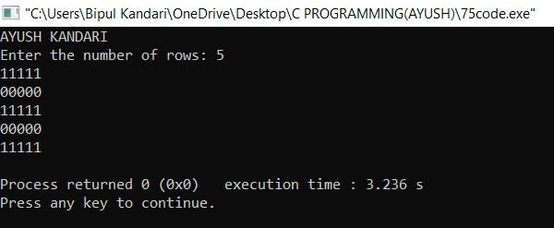

**81:**

**– 3.**

#include<stdio.h> int main(){ printf("AYUSH KANDARI\n"); int rows; printf("Enter the number of rows: "); scanf("%d",&rows); for(int i=1;i<=rows;i++){ for(int j=1;j<=rows;j++){ if(j%2==0){ printf("1");

} else{ printf("0");

}

}

printf("\n");

}

return 0;

}

**OUTPUT:**

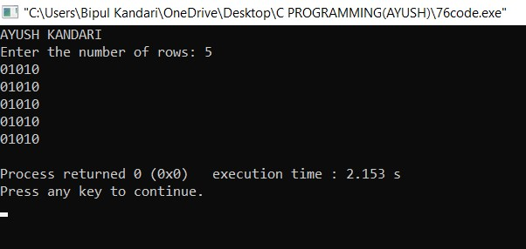

**82:**

**4.**

#include<stdio.h> int main(){ printf("AYUSH KANDARI\n");

int r;

printf("Enter the number of rows: "); scanf("%d",&r); for(int i=1;i<=r;i++){ for(int j=1;j<=r;j++){ if(i>1 && i<r){ if(j>1 && j<r){ printf("0");

} else{ printf("1");

} } else{ printf("1");

}

}

printf("\n");

}

return 0;

}

**OUTPUT:**

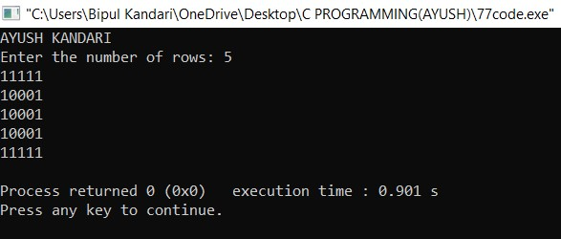

**83:**

**5.**

#include<stdio.h> int main(){ printf("AYUSH KANDARI\n");

int r;

printf("Enter the number of rows:"); scanf("%d",&r); for(int i=1;i<=r;i++){ for(int j=1;j<=r;j++){ if(i==j && i==r/2+1){ printf("0");

} else{ printf("1");

}

}

printf("\n");

}

return 0;

}

**OUTPUT:**

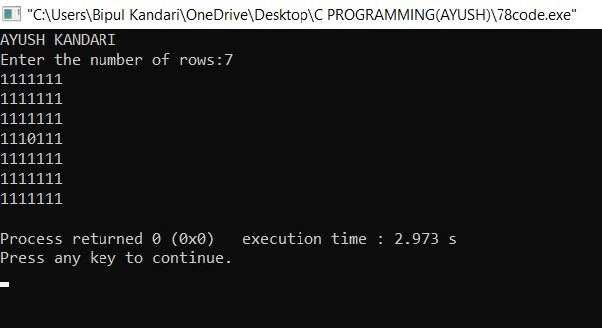

**84:**

**6.**

#include<stdio.h> int main(){ printf("AYUSH KANDARI\n"); int rows; printf("Enter the number of rows: "); scanf("%d",&rows); for(int i=1;i<=rows;i++){ for(int j=1;j<=rows;j++){ if(i%2==0){ if(j%2==0){ printf("1");

} else{ printf("0");

} } else{ if(j%2==0){ printf("0");

} else{ printf("1");

}

}

}

printf("\n");

}

return 0;

}

**OUTPUT:**

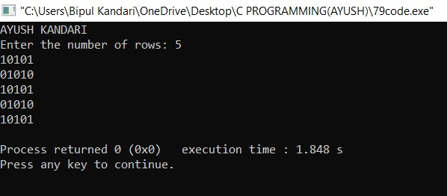

**85:**

**number is negative, positive or zero.**

**PROGRAM:**

#include<stdio.h> int main(){ printf("AYUSH KANDARI\n"); int num; printf("Enter a number: "); scanf("%d",&num); if(num>0){ printf("Positive");

}

else if(num<0){ printf("Negative");

}

else if(num==0){ printf("Zero");

}

else{ printf("Error"); }

return 0;

}

**OUTPUT:**

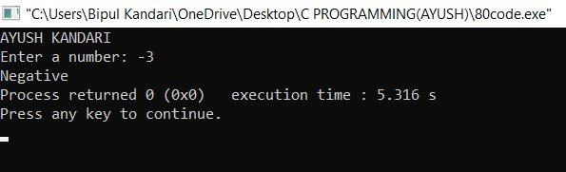

**86:**

**number is divisible by 5 and 11 or not.**

**PROGRAM:**

#include<stdio.h> int main(){ printf("AYUSH KANDARI\n"); int num; printf("Enter a number:"); scanf("%d",&num); if(num%5==0 && num%11==0){

printf("No. is divisible by both 5 and 11");

}

else{ printf("No. is not divisible by 5 or 11");

}

return 0;

}

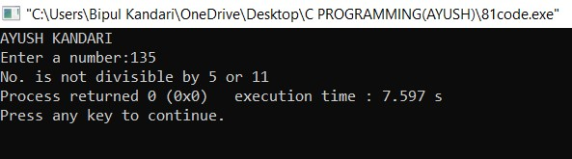

**87:WAP to check**

**year is leap year or not.**

**PROGRAM:**

#include<stdio.h> int main(){ printf("AYUSH KANDARI\n"); int num; printf("Enter a number: "); scanf("%d",&num); if(num%4==0 && num%100!=0){

printf("The year is leap year");

}

else{ printf("The year is not a leap year");

}

return 0;

}

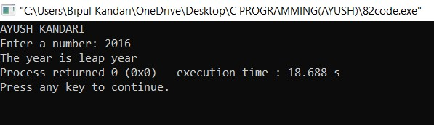

**88:WAP to check**

**character is alphabet or not.**

**PROGRAM:**

#include<stdio.h> int main(){ printf("AYUSH KANDARI\n"); char ch; printf("Enter a character:"); scanf("%c",&ch); int n=ch; if(n>=97 && n<=122){ printf("Yes, it is an alphabet");

}

else{ printf("No, it is not an alphabet");

}

return 0;

}

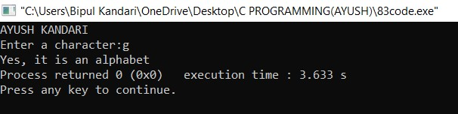

**89:Write a program to input any character**

**and check whether it is alphabet, digit or special character.**

**PROGRAM:**

#include<stdio.h> int main(){ printf("AYUSH KANDARI\n"); char ch; printf("Enter a character:"); scanf("%c",&ch); int c=ch; if(c>=48 && c<=57){

printf("Its a digit");

}

else if(c>=33 && c<=47){ printf("Its a Special character");

}

else if(c>=97 && c<=122){ printf("Its an Alphabet");

}

else{

printf("Invalid Input");

}

return 0;

}

**OUTPUT:**

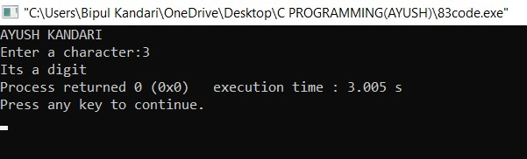

**90:Write a program to check whether**

**character is uppercase or lowercase alphabet.**

**PROGRAM:**

#include<stdio.h> int main(){ printf("AYUSH KANDARI\n"); char ch; printf("Enter the character: "); scanf("%c",&ch); int c = ch; if(c>=97 && c<=122){ printf("Character is in Lowercase");

}

else if(c>=65 && c<=90){ printf("Character is in Uppercase");

}

else{ printf("Invalid Input!!!");

}

return 0;

}

**OUTPUT:**

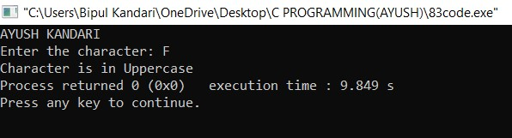

**91:Write a program to input week number**

**and print week day.**

**PROGRAM:**

#include<stdio.h> int main(){ printf("AYUSH KANDARI\n"); int num; printf("Enter the week number:"); scanf("%d",&num); if(num==1){ printf("Monday");

}

else if(num==2){ printf("Tuesday");

}

else if(num==3){ printf("Wednesday");

}

else if(num==4){ printf("Thrusday"); }

else if(num==5){ printf("Friday");

}

else if(num==6){ printf("Saturday");

}

else if(num==7){ printf("Sunday");

}

return 0;

}

**OUTPUT:**

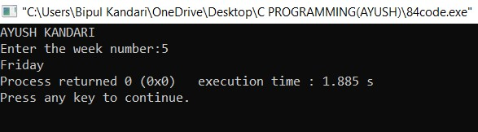

**92:Write a program to input month number and print number of days in that month.**

**PROGRAM:**

#include<stdio.h> int main(){ printf("AYUSH KANDARI\n"); int num; printf("Enter the month in number:"); scanf("%d",&num); if(num==1 || num==3 || num==5 || num==7 || num==8 || num==10 || num==12){

printf("31 Days");

}

else if(num==2){ printf("28 Days");

}

else if(num < 12){ printf("30 Days");

}

return 0;

}

**OUTPUT:**

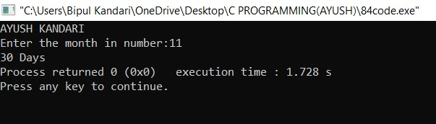

**93:Write a program to count total number**

**of notes in given amount.**

**PROGRAM:**

#include<stdio.h> int main(){ printf("AYUSH KANDARI\n"); int amt,n500=0,n200=0,n100=0,n20=0,n10=0,n1=0; printf("Enter the total number of amount: "); scanf("%d",&amt); while(amt!=0){ if(amt>=500){ n500=amt/500; amt=amt%500;

}

else if(amt<500 && amt>=200){ n200 = amt/200; amt=amt%200;

}

else if(amt<200 && amt>=100){ n100=amt/100; amt=amt%100;

}

else if(amt<100 && amt>=20){ n20=amt/20; amt=amt%20;

}

else if(amt<20 && amt>=10){ n10=amt/10; amt=amt%10;

}

else if(amt<10 && amt>=1){ n1=amt/1; amt=amt%1;

}

}

printf("500 notes: %d,\n200 notes: %d \n100 notes:

%d \n20 notes:%d \n10 notes: %d \n1 coins:

%d",n500,n200,n100,n20,n10,n1);

return 0;

}

**OUTPUT:**

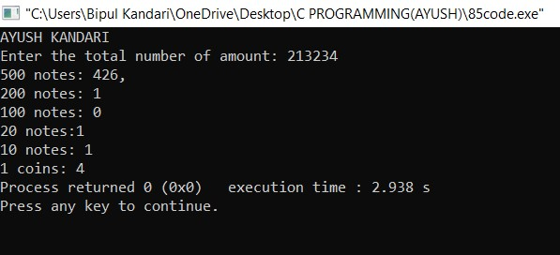

**94:Write a program to input angles of a**

**triangle and check whether triangle is valid or not.**

**PROGRAM:**

#include<stdio.h> int main(){ printf("AYUSH KANDARI\n"); int a1,a2,a3; printf("Enter First angle of triangle: "); scanf("%d",&a1); printf("Enter Second angle of triangle: "); scanf("%d",&a2); printf("Enter Third angle of triangle: "); scanf("%d",&a3); if(a1+a2+a3==180 && a1>0 && a2>0 && a3>0){

printf("The triangle is valid!!!");

}

else{ printf("Triangle is not valid!!!");

}

return 0;

}

**OUTPUT:**

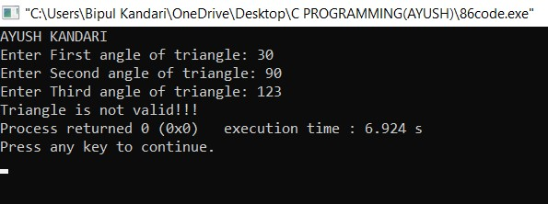

**95:Write a program to input all sides of a**

**triangle and check whether triangle is valid or not.**

**PROGRAM:**

#include<stdio.h> int main(){ printf("AYUSH KANDARI\n"); int side1, side2, side3; printf("Enter the first side of triangle: "); scanf("%d",&side1); printf("Enter the second side of triangle: "); scanf("%d",&side2); printf("Enter the third side of triangle: "); scanf("%d",&side3); if(side3>(side1+side2) || side1>(side2+side3) || side2>(side1+side3)){ printf("The Triangle is Valid!!!");

}

else{ printf("The Triangle is Invalid!!!");

}

return 0;

}

**OUTPUT:**

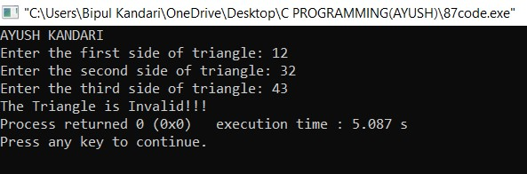

**96:Write a program to check whether the**

**triangle is equilateral, isosceles or scalene triangle.**

**PROGRAM:**

#include<stdio.h> int main(){ printf("AYUSH KANDARI\n"); int side1,side2,side3; printf("Enter first side of triangle: "); scanf("%d",&side1); printf("Enter second side of triangle: "); scanf("%d",&side2); printf("Enter third side of triangle: "); scanf("%d",&side3); if(side1==side2 && side2==side3){ printf("The triangle is Equilateral");

}

else if(side1==side2 || side2==side3 || side1==side3){

printf("Triangle is Isoceles");

}

else if(side1!=side2 && side2!=side3){ printf("Triangle is scalene");

}

return 0;

}

**OUTPUT:**

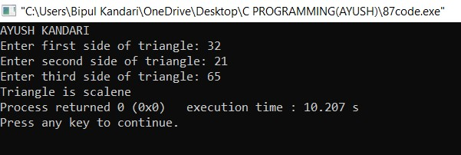

**97: Write a program to find all roots of a**

**quadratic equation.**

**PROGRAM:**

#include<stdio.h> #include<math.h> int main(){ printf("AYUSH KANDARI\n"); float a,b,c,r1,r2; printf("a: "); scanf("%f",&a); printf("b: "); scanf("%f",&b); printf("c: "); scanf("%f",&c); int d = (b*b) - (4*a*c); if(d>=0){ r1=(-b-sqrt(d))/(2*a); r2=(-b+sqrt(d))/(2*a); printf("Root1:%.2f\nRoot2:%.2f",r1,r2);

}

else if(d<0){

printf("Roots are Imaginary");

}

return 0;

}

**OUTPUT:**

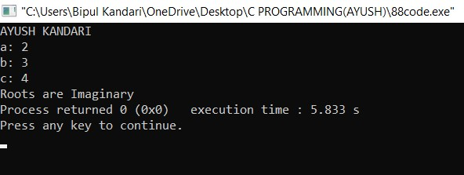

**98: Write a program to calculate profit and**

**loss.**

**PROGRAM:**

#include<stdio.h> int main(){ printf("AYUSH KANDARI\n");

int sell,cost; printf("Enter the Selling price: "); scanf("%d",&sell); printf("Enter the Cost Price: "); scanf("%d",&cost); if(sell>cost){ printf("Profit: %d",sell-cost);

}

else if(cost>sell){ printf("Loss: %d",cost-sell);

}

else if(cost==sell){ printf("No profit/loss");

}

return 0;

}

**OUTPUT:**

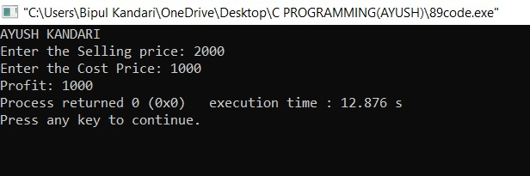

**99: Write a program to input basic salary**

**of an employee and calculate its Gross salary according to following:**

**Basic Salary <= 10000 : HRA = 20%, DA = 80%**

**Basic Salary <= 20000 : HRA = 25%, DA = 90% Basic Salary > 20000 : HRA = 30%, DA = 95%.**

**PROGRAM:**

#include<stdio.h> int main(){ printf("AYUSH KANDARI\n"); float sal,grosssal,hra,da; printf("Enter the employee salary:"); scanf("%f",&sal); if(sal<=10000){ hra=sal/5; da=(sal*4)/5;

}

else if(sal>=10000 && sal<=20000){ hra=sal/4; da=sal*0.9;

}

else if(sal>20000){

hra=sal*0.3; da=sal*0.95;

}

grosssal=sal+hra+da; printf("The Gross salary of the employee is:%.2f",grosssal); return 0;

}

**OUTPUT:**

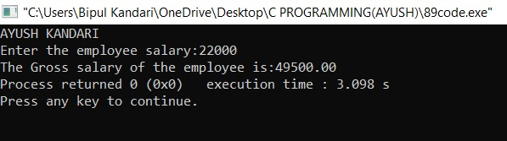

**100: Write a program to input electricity**

**unit charges and calculate total electricity bill according to the given conditions: For first 50 units Rs. 0.50/unit**

**For first 100 units Rs. 0.75/unit**

**For first 100 units Rs. 1.20/unit**

**For first above 250 Rs. 1.50/unit. An additional surcharge of 20% is added to the bill.**

**PROGRAM:**

#include<stdio.h> int main(){ printf("AYUSH KANDARI\n");

int unit; float charge; printf("Enter the total unit of electricity charge:"); scanf("%f",&unit); if(unit<=50){ charge=unit*0.5;

}

else if(unit>50 && unit<=150){ charge=25+(unit%50)*0.75; }

else if(unit>150 && unit<=250){ charge=100+(unit%150)*1.25;

}

else if(unit>250){ charge=225+(unit%250)*1.5;

}

charge=charge+(charge/5); printf("Total charge cost: %.2f",charge); return 0;

}

**OUTPUT:**

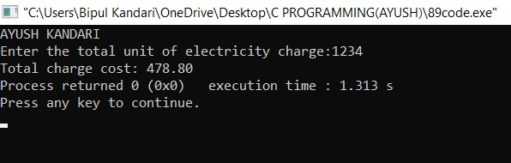

**101:WAP to read n number of values in an array display them in reverse order.**

**PROGRAM :**

#include<stdio.h> int main()

{

printf("AYUSH KANDARI\n"); int a[20],num,i; printf("Input the number of elements in the array:\n"); scanf("%d",&num); for(i=0;i<num;i++)

{

printf("a[%d]:\n",i); scanf("%d",&a[i]);

}

printf("The values stored in the array in reverse are:\n"); for(i=num-1;i>=0;i--)

{

printf("%d\t",a[i]);

} printf("\n"); return 0;

}

**OUTPUT:**

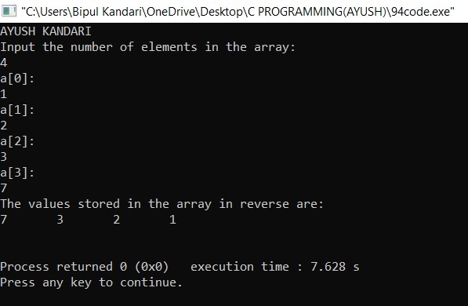

10**2:WAP to find the sum of all elements of an array.**

**PROGRAM :**

#include<stdio.h> int main()

{

printf("AYUSH KANDARI\n"); int a[20],num,i,sum=0; printf("Input the number of elements in the array:\n"); scanf("%d",&num); for(i=0;i<num;i++)

{

printf("a[%d]:\n",i); scanf("%d",&a[i]);

}

for(i=0;i<num;i++)

{

sum=sum+a[i];

}

printf("Sum=%d",sum);

return 0;

}

**OUTPUT:**

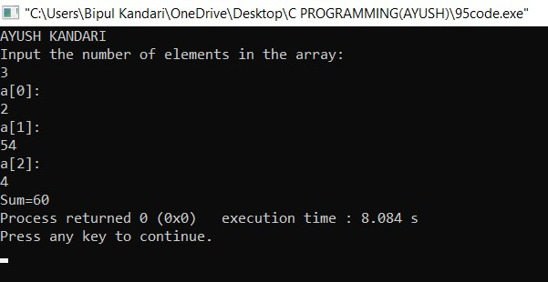

10**3: WAP to copy the elements of an array into another array.**

**PROGRAM:**

#include<stdio.h> int main()

{

printf("AYUSH KANDARI\n"); int a[20],b[20],num,i; printf("Enter number of elements in array 'a':\n"); scanf("%d",&num); for(i=0;i<num;i++)

{

printf("a[%d]:\n",i); scanf("%d",&a[i]);

}

for(i=0;i<num;i++)

{ b[i]=a[i];

}

printf("Copied elements in array b="); for(i=0;i<num;i++)

{

printf("%d ",b[i]);

}

return 0;

}

**OUTPUT:**

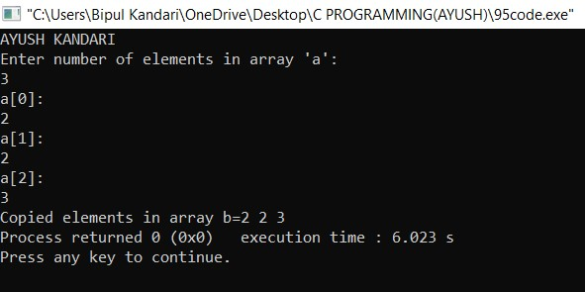

10**4: WAP to count the number of duplicate elements in an array.**

**PROGRAM:**

#include<stdio.h> int main()

{

printf("AYUSH KANDARI\n"); int array[100]; int i,j,num,count=0; printf("Enter number of elements in Array\n"); scanf("%d",&num); printf("Enter the elements:"); for(i=0;i<num;i++){ scanf("%d",&array[i]);

}

for(i=0;i<num;i++)

{

for(j=i+1;j<num;j++)

{

if(array[i]==array[j])

{

count++; break;

}

}

}

printf("Number of Duplicate elements=

%d\n",count); return 0;

}

**OUTPUT:**

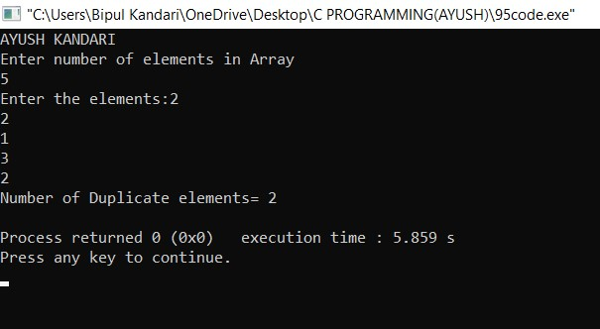

10**5:WAP to print maximum and minimum elements of an array.**

**PROGRAM:**

#include<stdio.h> int main()

{

printf("AYUSH KANDARI\n"); int a[10],i,max,min,num; printf("Enter number of elements in Array\n"); scanf("%d",&num); printf("Enter the elements:"); for(i=0;i<num;i++){ scanf("%d",&a[i]);

}

max=a[0]; min=a[0]; for(i=0;i<num;i++)

{

if(max<a[i]) max=a[i];

else if(a[i]<min) min=a[i];

}

printf("%d is maximum and %d is minimum.",max,min);

return 0;

}

**OUTPUT:**

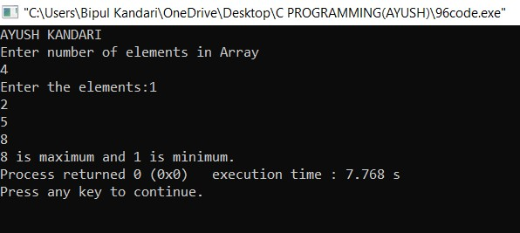

10**6:WAP to print the elements of an array in descending order.**

**PROGRAM:**

#include<stdio.h> int main()

{

printf("AYUSH KANDARI\n"); int a[4]={112,6,94,23}; int n=4,i,j,k=0; for(i=0;i<n;i++)

{

for(j=i+1;j<n;j++)

{ if(a[i]<a[j])

{ k=a[i]; a[i]=a[j]; a[j]=k; }

}

}

for(i=0;i<n;i++) { printf("%d\t",a[i]);

}

return 0;

}

**OUTPUT:**

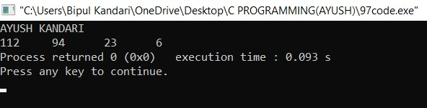

10**7:WAP to separate odd and even integers into separate arrays.**

**PROGRAM:**

#include <stdio.h> int main()

{

printf("AYUSH KANDARI\n"); int a[10],num,i; printf("Enter no. of elements in Array.\n"); scanf("%d",&num); printf("Enter elements of the Array.\n"); for(i=0;i<num;i++)

{

scanf("%d",&a[i]);

}

printf("Even elements of the array are:"); for(i=0;i<num;i++)

{

if(a[i]%2==0)

{

printf("%d",a[i]);

}

}

printf("\nOdd elements of the array are: "); for(i=0;i<=num;i++)

{

if(a[i]%2==1)

{

printf("%d ",a[i]);

}

}

return 0;

}

**OUTPUT:**

